1. Add a new connection manager by right-clicking the Connection Managers window and selecting New Connection.

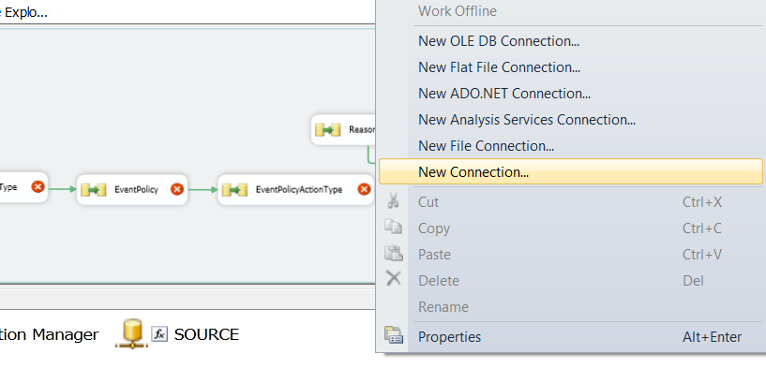

2.    When prompted for the type, select HTTP and click the Add button.  This opens the HTTP Connection Manager Editor.

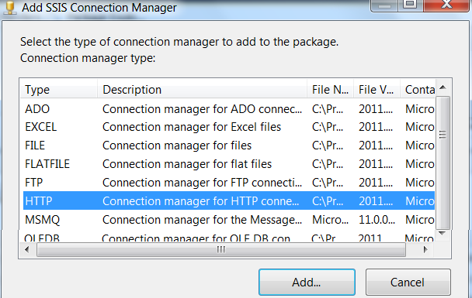

3.    Enter the location of the web service WSDL file in the Server URL field.  In this case, we are calling a web service that returns a stock quote.

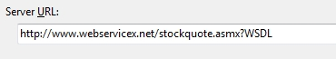

4.    Click the Test Connection button.  If the test succeeds, click Ok to close the editor window.

5.    Next, add a **File Connection Manager.**

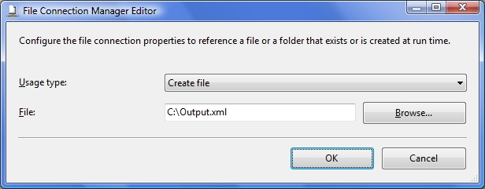

6. In the editor window, select **Create File for Usage** type and enter a file name of Output.xml in your chosen directory.  Click Ok to close the editor window.

7.    The Connection Managers window should resemble the following.

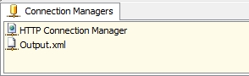

8.    Next, add a **Web Service Task to the packag**e; open the task editor and select the General page.

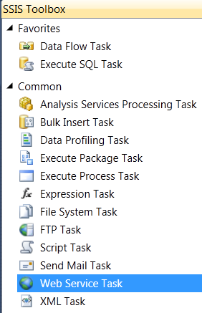

9.    Under the Connection group, set the HTTPConnection option by selecting the HTTP Connection Manager that was created earlier.

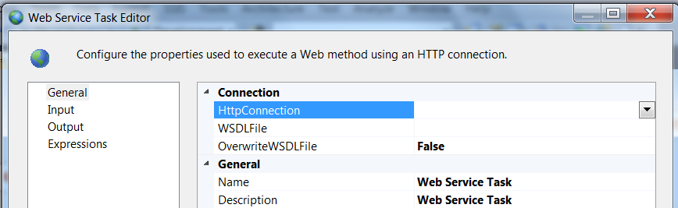

10.    Then set the **WSDLFile** value by clicking the ellipsis button and navigating to the local copy of the web service’s WSDL file.  If you have not already downloaded the WSDL file manually, you can create an empty file and set the OverwriteWSDLFile option to True and click the Download WSDL button.

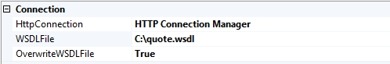

11.    Next, select the **Input tab** and set the Service option by selecting **StockQuote** in the drop-down list.

12.    Set the Method option by selecting **GetQuote** in the drop-down list.

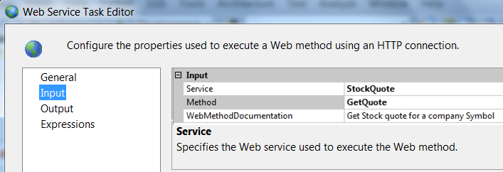

13.    After selecting a Method, the option to enter a value is displayed.  Select the Variable check box and select the **User::StockSymbol** variable that was created earlier.  Also make sure Type is **String**.

Variable

14.    Next, select the **Output tab** and set the **OutputType** to File Connection.

15.    For the File option, select the file connection manager which was created earlier.

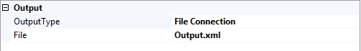

16.    Click the Ok button to close editor.

17.    Run the package and view the Output.xml file.  The results should be similar to the following.

<?xml version="1.0" encoding="utf-16" ?>   
<string>  
<StockQuotes><Stock><Symbol>MSFT</Symbol><Last>30.875</Last><Date>4/29/2010</Date><Time>11:19am</Time>  
<Change>-0.035</Change><Open>30.96</Open><High>30.97</High><Low>30.67</Low><Volume>17750884</Volume>  
<MktCap>270.6B</MktCap><PreviousClose>30.91</PreviousClose><PercentageChange>-0.11%</PercentageChange>  
<AnnRange>19.01 - 31.58</AnnRange><Earns>1.93</Earns><P-E>16.02</P-E><Name>Microsoft Corpora</Name>  
</Stock></StockQuotes>  
</string>

In this case the SSIS generates the output in a xml file.

ANOTHER OPTION, TAKE THE XML FILE GENERATED

11. Next select the Input page and set the **Service** option by selecting the **currencyconvertor** and method as **conversionrate** in the drop-down list. And select the currency also for the conversion i.e:

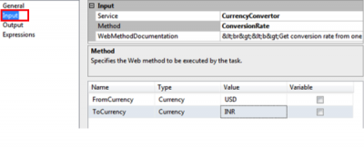

12. Next, select the output page and output type as variable and select variable as **User::ConversionRateResponse** in the dropdown.

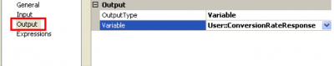

13. Now drag and drop “**XML Task**” from the toolbox to the Control Flow window.

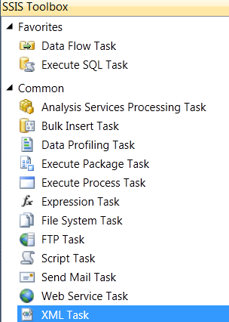

Then Right click on it and say edit the XML Task to open up the editor window and set the properties under general tab as shown in the snippet below.

14. The XML Task Editor should be configured with the details as shown in the below table.

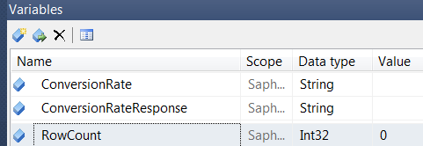

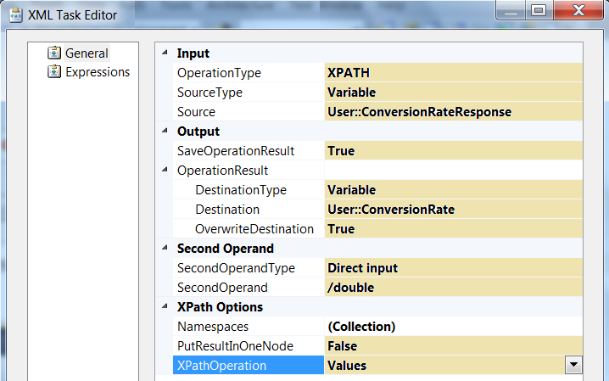

15. Drag and drop a **Dataflow task** on Control flow tab and double click on it u will be directed      to Dataflow window



16. Now drag and drop **OLEDBsource** and right click on it and say edit and write the following query:

**SELECT Lastname,SalesYTD FROM Sales.VSalesPerson**

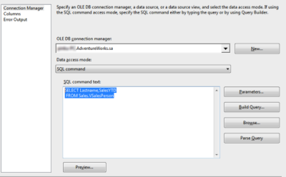

17. Drag and drop **derived column** (used for deriving a new column).Write the new column name has**salesYTDINR**(converted currency to Indian rupee) And write the expression as  following **ROUND([SalesYTD]* (DT_R8) @[User::ConversionRate],2)**

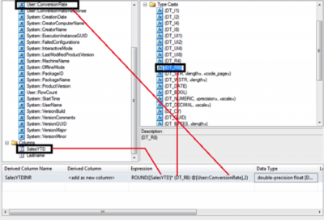

18. Drag and drop RowCount and set the property variable name as User::RowCount from the drop down list.

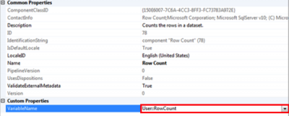

19. Right click on the connection between the derived column and the RowCount and select DataViewers.

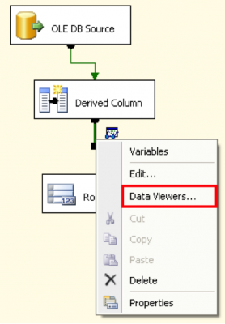

20. Now click on the DataViewers you will get a screen in that you will have General,Metadata and DataViewers

21. Select **DataViewers** and click on add button and select GridView.

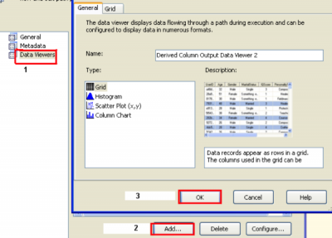

22. Finally to execute the package, right click the **WebServiceTaskExample.dtsx** package from the solution explorer and select the **Execute Package option Or Simply Press “f5”.** Once the package has successfully executed you will be able to see the below screen within the control flow designer.

MAIN INSIDE DATA FLOW TASK

